Paper summary

Band: Coordinated Multi-DNN Inference on Heterogeneous Mobile Processors

0. Abstract
- core features of Band
- deal with multi-DNN workload
- not model/operator level scheduling, subgraph level scheduling
- consider fallback operator // only avaliabel at certain processors(CPU etc)

1. Introduction
- deals with problem mentioned in abstract

2. Workload characteristics
- characteristics of multi-DNN tasks
- needs minimization of makespan
- usually have latency-critical tasks
- have dynamic features
- fore/backgournd apps co-execution to achieve complex goal

3. Motivation-unified
- of course, it is better to utilize all avaliable processors // cpu, gpu, npu, dsp etc
- there are some challenges about coordination
1. multi-DNN model to certain processor(one), processor contention -> perf degrade
2. fallback operators -> siliently fall back to cpu, underutillization of processors
3. performance uncertainty

4. Band: subgraph-centric coordination
4.1 System overview
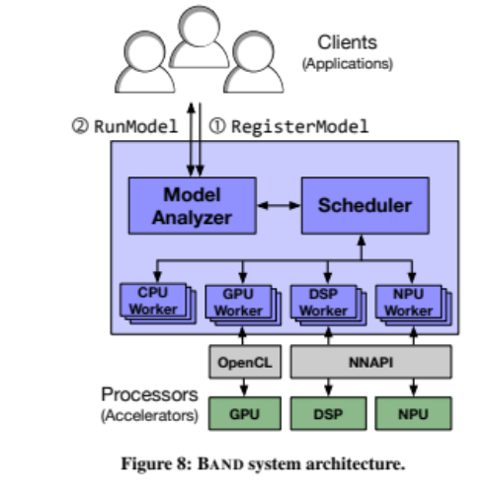
- model analyzer : subgraph-making
- scheduler : assign subgraph to processors, by dequeue item from job queue

4.2, 4.3 Subgraph Partitioning and scheduling
- unit : adjacent operator can be processed at same processor
- subgraph : merge of units
- getnextjob gets subgraph(not fifo) from job queues, execute subgraph, run others
- pluggable policies // ex : LST policy(default)
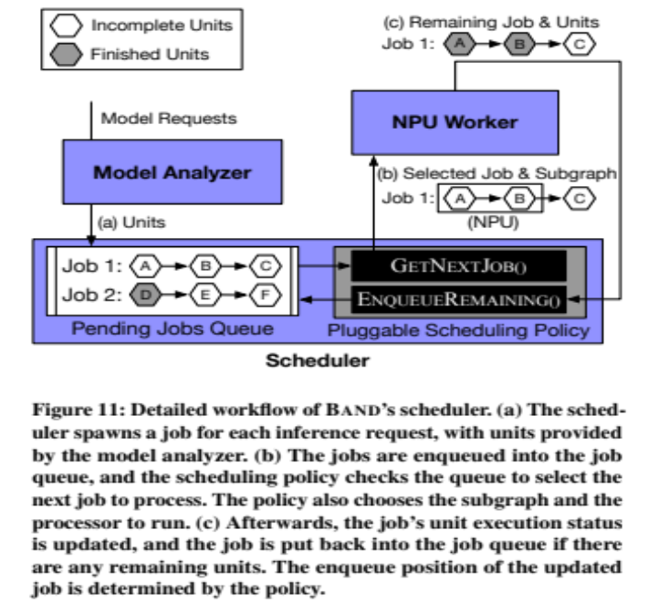
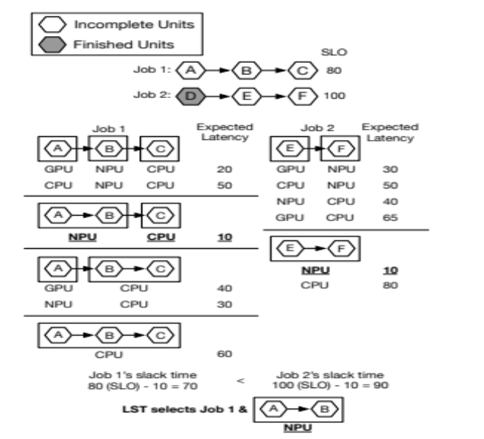
- when thermal shutdown happens, exclude that processor from job-running candidate until it becomes online again
- offline profiling by running models several times, estimate latency of each subgraph with some speculation formulas, then EDMA manner online adjustment of latency profile

(cf)
// estimate subgraph latency from largest subgraph latency

